> setwd("/media/user/软件/learnSpector/SDWorkshop-main")
> library(ggplot2)
> library(readr)
> library(dplyr)
> d <- read_csv("datasets/single runs/LTG.csv")
Rows: 793 Columns: 7
── Column specification ────────────────────────────────────────────────
Delimiter: ","
dbl (7): Year, Additions, Carrying Capacity, Constrained Growth Rate...

ℹ Use `spec()` to retrieve the full column specification for this data.
ℹ Specify the column types or set `show_col_types = FALSE` to quiet this message.
> ggplot(d,aes(x=Year,y=Population)) +
+ geom_point()+geom_line()

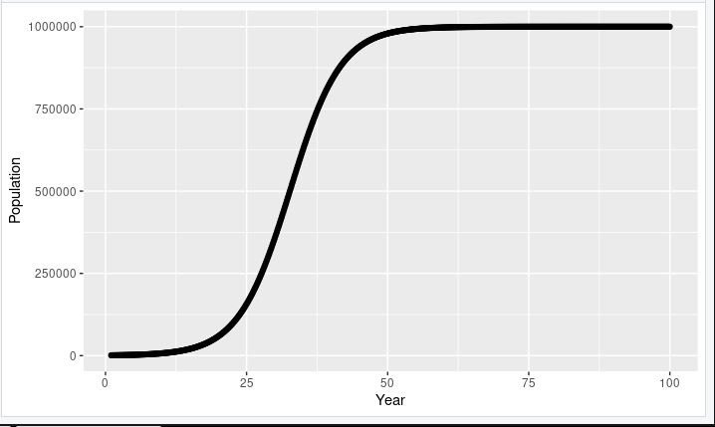

> d <- d %>%
+ mutate(ModeValue=round(c(NA,NA,diff(abs(diff(Population)))),3),
+ Mode=as.factor(ifelse(ModeValue>0,"EXP",
+ ifelse(ModeValue<0,"LOG","LIN"))))
> ggplot(d,aes(x=Year,y=Population,colour=Mode)) +
+ geom_point()+theme_light()

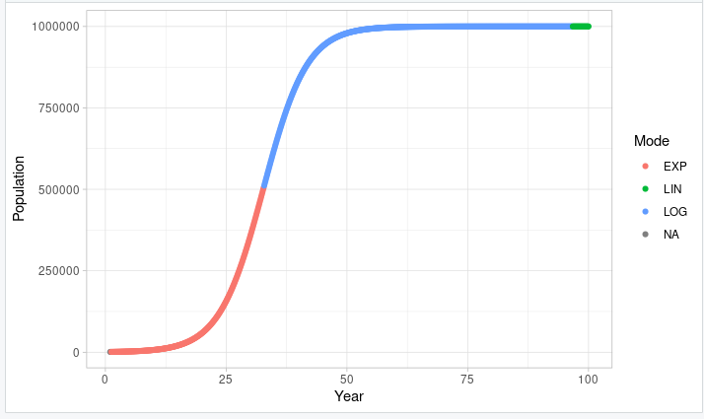

> ggplot(d,aes(x=Year,y=Population,colour=Mode)) +
+ geom_point()+geom_line()+theme_classic()

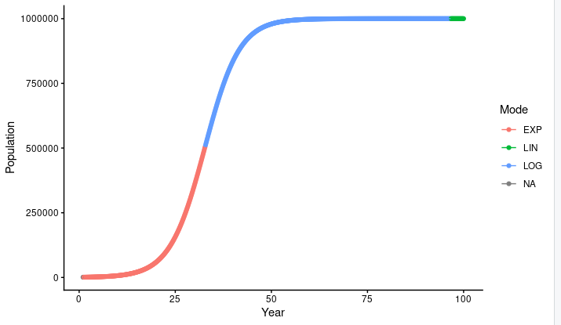

> ggplot(d,aes(x=Year,y=Population,colour=Mode)) +
+ geom_point()+geom_line()+theme_classic()+facet_wrap(~Mode)

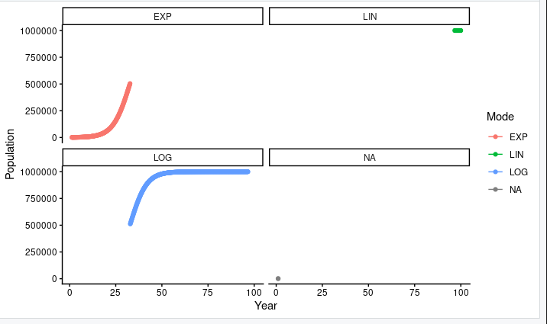

> ggplot(d,aes(x=Additions,y=Population,colour=Mode))+geom_point()

